UNIT-1
Introduction to Game Development: Overview of game development, history of games, basics of game engine. Different roles in game development. Getting Started with Unity: Installation, version control, Unity interface, importing or creating assets, game objects and game components, scripts in unity.

UNIT-2
Game Development in Unity: Render pipeline, Package manager, 2D vs 3D, visual scripting, post processing, shader graph, pro builder.Scripting in Unity: C# programming in Unity, basic C# concepts, introduction to unit tests, game physics, scripting game mechanics, game state management, player input and controls.

UNIT-3
Game Development in Unity Continued: UI Toolkit, assembly definition, nav mesh, Input system, Animation, Json utility, Addressable, Multiplayer, Localization. Scripting in Unity
Continued: NPCs in games, Inventory system, object pool, Unit test, SOLID principle, Design patterns, Debugging and profiling, Dots and ECSContemporary Issues & Opportunities: Trends, challenges, and case studies in modern game development.

Unity Lab Manual

Lab 1: Create a Balance Primitive Structure.
Objective: Create a balanced structure using Unity primitive objects and Rigidbody physics components to observe how mass affects balance.

Lab 2: Materials and Asset Importing
Objective: Learn how to import textures, create a material, and apply it to a 3D object in Unity.

Lab 3: Basic Transform Manipulation via Script
Objective: Learn how to manipulate a GameObject's Transform component through scripting by continuously rotating a cube around its Y-axis.

Lab 4: Instantiation and Destruction
Objective: Learn how to create a Prefab, instantiate (spawn) it using a script when the Spacebar is pressed, and automatically destroy the spawned object after 3 seconds.

Lab 5: 3D Cube Movement & Boundary Checks
Objective: Work with 3D elements and player input by moving a 3D character cube using the Arrow Keys or WASD keys through Input.GetAxis().

Lab 6: 2D Sprite Movement & Boundary Checks
Objective: Work with 2D elements and player input by moving a 2D character sprite using the Arrow Keys or WASD keys. Implement boundary checks to prevent the sprite from moving outside the game screen.

Lab 7: Rigidbody Physics and Colliders
Objective: Understand Unity's Physics Engine by creating a sphere with a Rigidbody component and detecting collisions with a wall using OnCollisionEnter().

Lab 8: Custom Shaders with Shader Graph
Objective: Create a scrolling road effect using Shader Graph by offsetting a texture over time. This technique is commonly used for endless roads, conveyor belts, and moving backgrounds.

Lab 9: Post-Processing Effects
Objective: Learn how to use Unity's Volume Component to add post-processing effects such as Bloom, Color Adjustments, and Depth of Field to improve the visual quality of a scene.

Lab 10: Basic Transform Manipulation via Visual Scripting
Objective: Learn the basics of Unity Visual Scripting by creating a State Machine that continuously rotates a Cube around its Y-axis without writing any code.

Lab 11: Creating a UI Canvas
Objective: Create a 2D game main menu screen using Unity UI components. Set the provided assets as the background, logo, and menu buttons.

Lab 12: Game State Management
Objective: Understand and implement a basic Game State Management System in Unity using C#. Learn how to manage different game states such as Main Menu, Playing, Paused, Game Over, and Win.

Lab 13: Pathfinding with NavMesh
Objective: Learn how to use Unity's NavMesh system to create AI pathfinding. A player object will move automatically to the location clicked by the user while avoiding obstacles.

Lab 14: JSON Serialization for Login
Objective: Learn how to use JSON Serialization in Unity to store and retrieve user login credentials using a local JSON file. Implement a simple Login and Registration system using TextMeshPro UI.

Lab 15: Creating a Cube Rotation Animation
Objective: Learn how to create a basic animation in Unity using the Animation Window. Animate a cube to rotate continuously around the Y-axis.

Create a Balanced Primitive Structure

Objective
Create a balanced structure using Unity primitive objects and Rigidbody physics components to observe how mass affects balance.

Step 1: Create a New Unity Project
- Open Unity Hub.
- Click New Project.
- Select 3D (Core) template.
- Enter the project name BalancedPrimitiveStructure.
- Choose a project location.
- Click Create Project.

Step 2: Create a New Scene
- In the Project Window, navigate to the Assets folder.
- Right-click and select Create → Folder.
- Name the folder Scenes.
- Open the Scenes folder.
- Right-click and select Create → Scene.
- Name the scene Primitive Structure.
- Double-click the scene to open it.
- Save the scene (Ctrl + S).

Step 3: Create a Plane
- In the Hierarchy Window, right-click.
- Select 3D Object → Plane.
- Select the Plane.
- In the Inspector Window, click the gear icon (or three dots) in the Transform component.
- Select Reset.

Step 4: Create the Base Support Cube
- Right-click in the Hierarchy.
- Select 3D Object → Cube.
- Rename it Base Support.
- Set the Transform values:
  - Position (0, -0.03, 0)
  - Rotation (45, 90,0)

Step 5: Create the Balance Beam
- Create another Cube.
- Rename it Balance Beam.
- Set the Transform values:
  - Position (0, 0.72, 0)
  - Scale(10, 0.1, 1)

Step 6: Create the Left Weight
- Create a new Cube.
- Rename it Left Weight.
- Set the Transform values:
  - Position (-4.5, 1.27, 0)
- Add a Rigidbody:
  - Click Add Component.
  - Search for Rigidbody.
  - Select Rigidbody.
- Set:
  - Mass = 2

Step 7: Create the First Right Weight
- Create another Cube.
- Rename it Right Weight 1.
- Set the Transform values:
  - Position (4.5, 1.27, 0)
- Add a Rigidbody component.
- Set:
  - Mass = 1

Step 8: Create the Second Right Weight
- Create another Cube.
- Rename it Right Weight 2.
- Set the Transform values:
  - Position (4.5, 2.27, 0)
- Add a Rigidbody component.
- Set:
  - Mass = 1

Step 9: Test the Balanced Structure
- Save the scene.
- Click the Play button at the top of the Unity Editor.
- Observe the behavior of the structure.

Expected Result
- The cube on the left has a mass of 2.
- The two cubes on the right each have a mass of 1.
- Since the total mass on both sides is equal (2 = 1 + 1), the beam should appear balanced.
- Unity physics demonstrates the concept of equilibrium and center of mass.

Screenshot
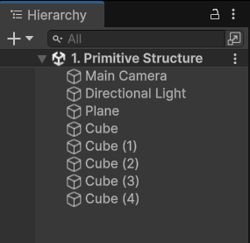
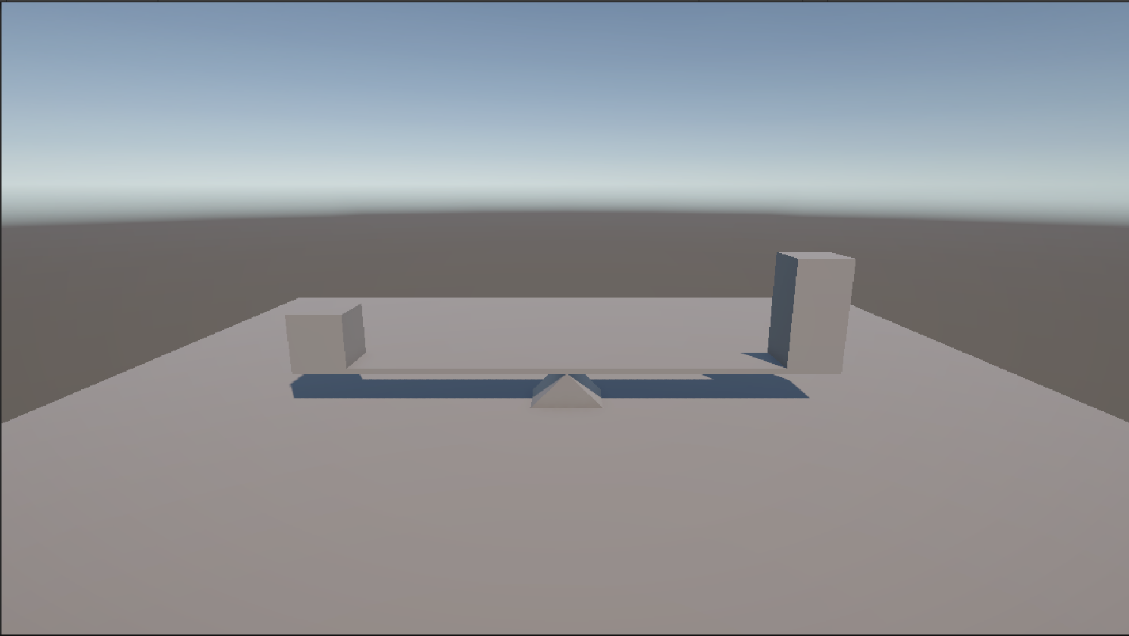

Applying Assets and Materials

Objective
Learn how to import textures, create a material, and apply it to a 3D object in Unity.

Step 1: Create a New Unity Project
- Open Unity Hub.
- Click New Project.
- Select the 3D (Core) template.
- Enter a project name.
- Choose a project location.
- Click Create Project.

Step 2: Create a New Scene
- In the Project Window, navigate to the Assets folder.
- Right-click and select Create → Scene.
- Rename the scene as Asset & Material.
- Double-click the scene to open it.
- Save the scene (Ctrl + S).

Step 3: Create a Plane
- In the Hierarchy Window, right-click.
- Select 3D Object → Plane.
- Select the Plane object.
- In the Inspector Window, click the gear icon (or three dots) in the Transform component.
- Select Reset.

Step 4: Import Texture Maps and Create a Material
- Import Texture Maps
- Open the folder containing the texture files.
- Drag and drop the following files into the Assets folder:
- Brick_Diffusion_Map (Albedo Texture)
- Brick_Normal_Map
- Create a Material
- In the Project Window, right-click inside the Assets folder.
- Select Create → Material.
- Rename the material as Asset_Material.

Step 5: Configure the Material
- Select Asset_Material.
- In the Inspector Window, locate the Base Map property.
- Drag the Diffusion Map texture into the Base Map slot.
- Locate the Normal Map property.
- Drag the Normal Map texture into the Normal Map slot.
- If Unity prompts "Fix Now" for the normal map, click Fix Now.
Note: Change the tiling as (3,3) for this project only.

Step 6: Apply the Material to the Plane
- Select the Plane object in the Hierarchy.
- Drag the Asset_Material from the Project Window onto the Plane.
OR
- In the Plane's Mesh Renderer component, drag the material into the Materials slot.

Expected Result
- The Plane displays the Diffusion (Albedo) texture.
- Surface details from the Normal Map are visible when light falls on the Plane.
- The Plane appears more realistic with texture and surface depth effects.

Screenshots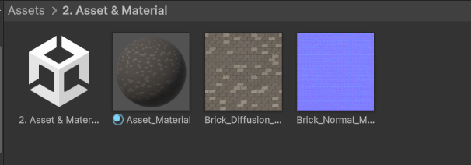
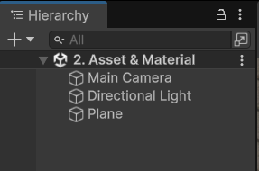
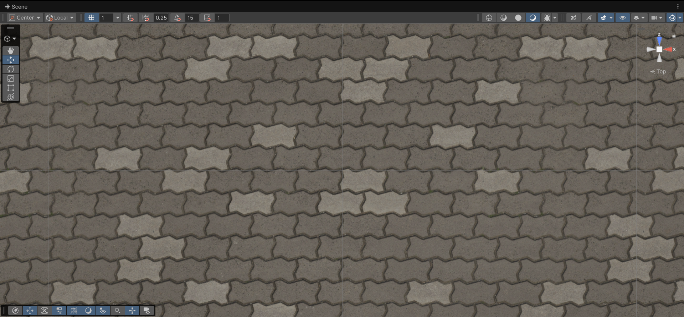

Basic Transform Manipulation via Script

Objective
Learn how to manipulate a GameObject's Transform component through scripting by continuously rotating a cube around its Y-axis.

Step 1: Create a New Unity Project
- Open Unity Hub.
- Click New Project.
- Select the 3D (Core) template.
- Enter a project name.
- Choose a project location.
- Click Create Project.

Step 2: Create a New Scene
- In the Project Window, right-click inside the Assets folder.
- Select Create → Scene.
- Rename the scene as Transform Manipulation.
- Double-click the scene to open it.
- Save the scene (Ctrl + S).

Step 3: Create a Cube
- In the Hierarchy Window, right-click.
- Select 3D Object → Cube.
- Rename the object as Cube.
- Select the Cube.
- In the Inspector Window, click the gear icon (or three dots) in the Transform component.
- Select Reset.

Step 4: Create a Script
- In the Project Window, right-click inside the Assets folder.
- Select Create → C# Script.
- Rename the script as RotateObject.
- Double-click the script to open it in Visual Studio or your preferred code editor.

Step 5: Write the Script

- Replace the existing code with the following:

using UnityEngine;

public class RotateObject : MonoBehaviour
{
[Header("Rotation Settings")]
[Tooltip("Rotation speed in degrees per second.")]
public float rotationSpeed = 50f;

// Update is called once per frame
void Update()
{
// Calculate the rotation amount for this frame
float rotationAmount = rotationSpeed * Time.deltaTime;

// Rotate only around the Y-axis (Up)
transform.Rotate(0f, rotationAmount, 0f);
}
}

Code Explanation
- rotationSpeed controls how fast the cube rotates.
- Time.deltaTime ensures smooth rotation regardless of frame rate.
- transform.Rotate() rotates the object every frame.
- The cube rotates only around the Y-axis.

Step 6: Attach the Script to the Cube
- Return to Unity.
- Wait for Unity to compile the script.
- Select the Cube GameObject in the Hierarchy.
- Drag the RotateObject script from the Project Window onto the Cube.
OR
- Click Add Component in the Inspector and search for RotateObject.
- Verify that the script appears in the Cube's Inspector.

Step 7: Play the Game
- Save the scene (Ctrl + S).
- Click the Play button at the top of the Unity Editor.
- Observe the Cube rotating continuously around its Y-axis.

Expected Result
- The Cube rotates smoothly around its vertical (Y) axis.
- The rotation speed is controlled by the Rotation Speed variable in the Inspector.
- Changing the value while the game is running affects the rotation speed.

Screenshots
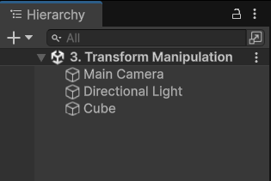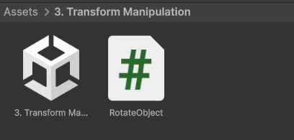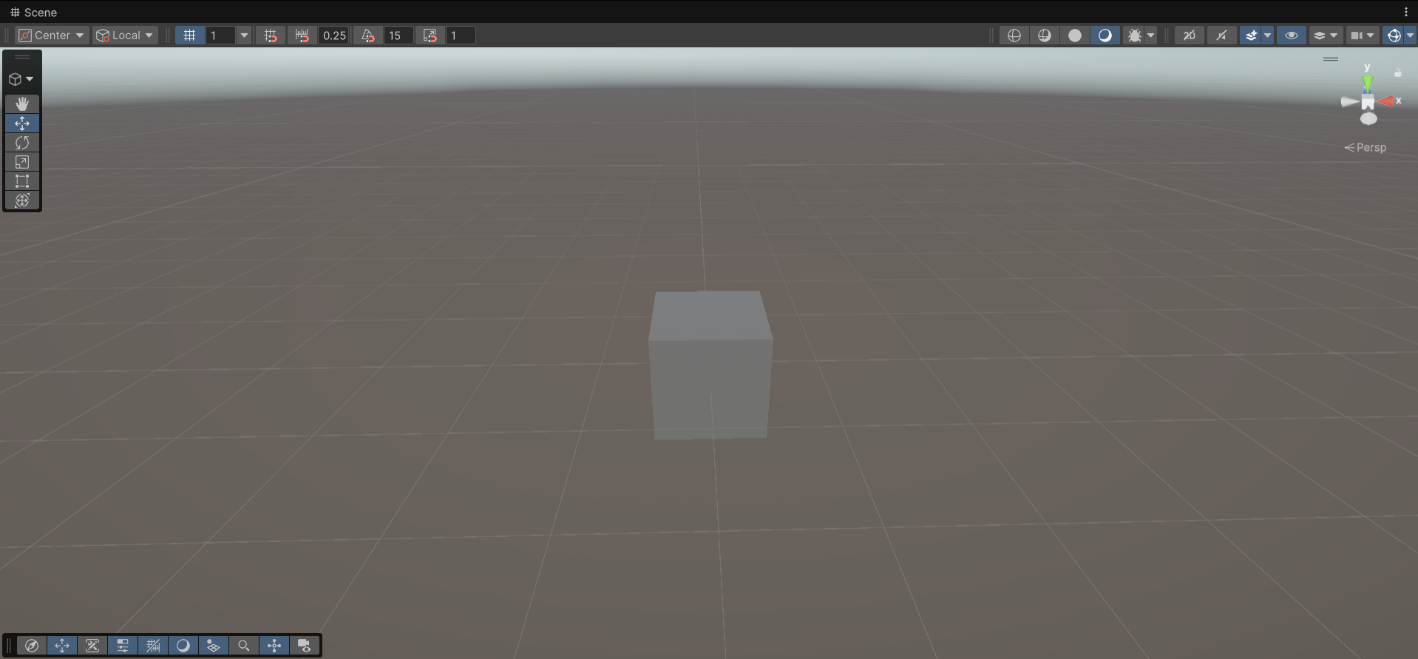

Instantiation and Destruction

Objective
Learn how to create a Prefab, instantiate (spawn) it using a script when the Spacebar is pressed, and automatically destroy the spawned object after 3 seconds.

Step 1: Create a New Unity Project
- Open Unity Hub.
- Click New Project.
- Select the 3D (Core) template.
- Enter a project name.
- Click Create Project.

Step 2: Create a New Scene
- In the Project Window, right-click inside the Assets folder.
- Select Create → Scene.
- Rename the scene as Prefab Spawn.
- Open and save the scene.

Step 3: Create a Sphere
- In the Hierarchy Window, right-click.
- Select 3D Object → Sphere.
- Rename it as SpherePrefab.
- Set its position to (0, 0.5, 0).

Step 4: Create a Prefab
- In the Project Window, create a folder named Prefabs.
- Drag the SpherePrefab GameObject from the Hierarchy into the Prefabs folder.
- A blue prefab asset is created.
- Delete the Sphere from the Hierarchy (the prefab asset remains in the Project window).

Step 5: Create an Empty GameObject
- Right-click in the Hierarchy.
- Select Create Empty.
- Rename it as Spawner.

Step 6: Create a Script
- In the Assets folder, right-click.
- Select Create → C# Script.
- Rename the script as SphereSpawner.
- Open the script in Visual Studio.

Step 7: Write the Script
- Replace the default code with:

using UnityEngine;

public class SphereSpawner : MonoBehaviour
{
[Header("Prefab Settings")]
public GameObject spherePrefab;

[Header("Spawn Position")]
public Vector3 spawnPosition = new Vector3(0, 1, 0);

void Update()
{
// Check if Spacebar is pressed
if (Input.GetKeyDown(KeyCode.Space))
{
// Spawn the sphere prefab
GameObject spawnedSphere = Instantiate(
spherePrefab,
spawnPosition,
Quaternion.identity);

// Destroy after 3 seconds
Destroy(spawnedSphere, 3f);
}
}
}

Step 8: Attach the Script
- Return to Unity.
- Select the Spawner GameObject.
- Click Add Component.
- Add the SphereSpawner script.

Step 9: Assign the Prefab
- Select the Spawner GameObject.
- In the Inspector, locate the Sphere Prefab field.
- Drag the SpherePrefab asset from the Prefabs folder into the field.

Step 10: Test the Project
- Save the scene.
- Click Play.
- Press the Spacebar.

Note: If you get any the error InvalidOperationException: You are trying to read Input using the UnityEngine.Input class, but you have switched active Input handling to Input System package in Player Settings.
- Go to Edit > Project Settings from the top menu.
- Select the Player category on the left panel.
- Expand the Other Settings dropdown on the right side.
- Scroll down to the Configuration section and find Active Input Handling.
- Change the dropdown selection from Input System Package (New) to Both.
- Unity will prompt you to apply the changes and restart the editor. Click Apply.

Expected Result
- A Sphere appears at position (0, 1, 0).
- Every time the Spacebar is pressed, a new Sphere is spawned.
- Each spawned Sphere automatically disappears after 3 seconds.

Screenshots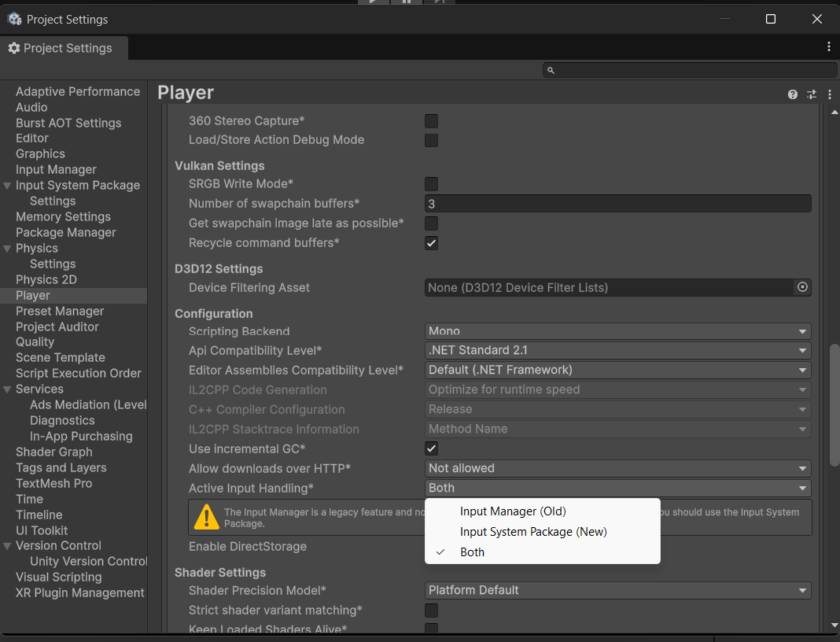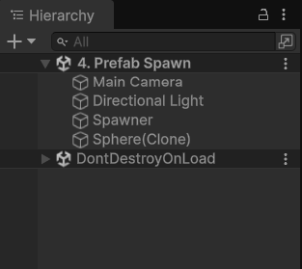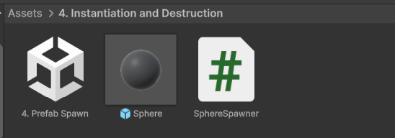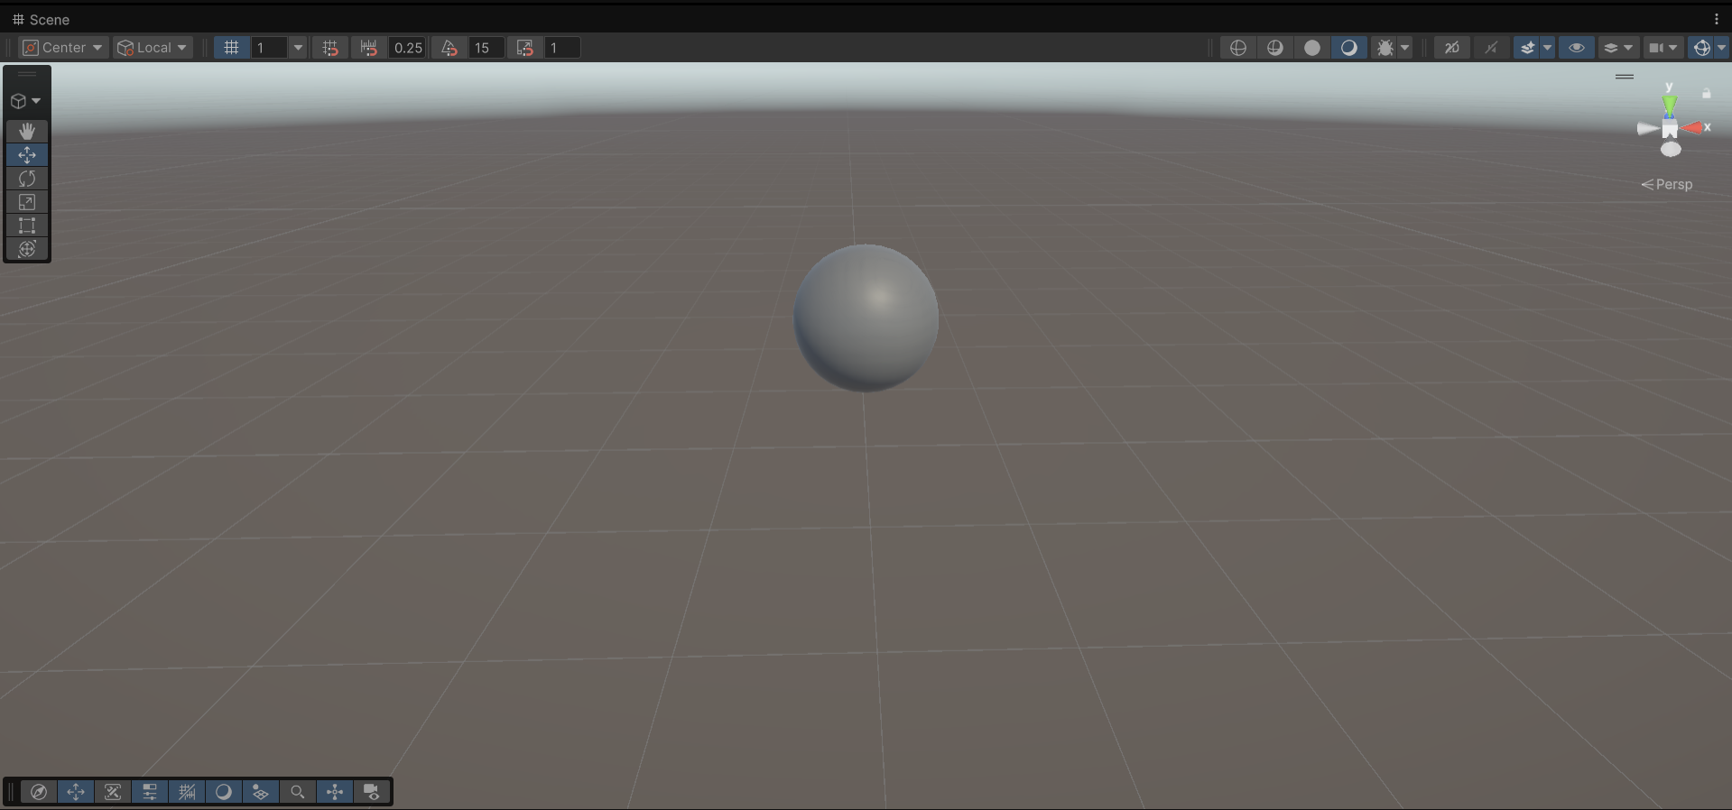

3D Cube Movement

Objective
Work with 3D elements and player input by moving a 3D character cube using the Arrow Keys or WASD keys through Input.GetAxis().

Step 1: Create a New Unity Project
- Open Unity Hub.
- Click New Project.
- Select the 3D (Core) template.
- Enter a project name.
- Click Create Project.

Step 2: Create a New Scene
- In the Project Window, right-click inside the Assets folder.
- Select Create → Scene.
- Rename the scene as Cube Movement.
- Open and save the scene.

Step 3: Create a Ground Plane
- In the Hierarchy Window, right-click.
- Select 3D Object → Plane.
- Rename it as Ground.
- Reset the Transform component.

Step 4: Create a Player Cube
- Right-click in the Hierarchy.
- Select 3D Object → Cube.
- Rename it as Player.
- Set its position above the plane.
  - Position (0, 0.5, 0)

Step 5: Create a Movement Script
- In the Project Window, right-click inside the Assets folder.
- Select Create → C# Script.
- Rename the script as CubeMovement.
- Open the script in Visual Studio.

Step 6: Write the Script
Replace the default code with:

using UnityEngine;

public class CubeMovement : MonoBehaviour
{
[Header("Movement Settings")]
public float moveSpeed = 5f;

void Update()
{
// Get keyboard input
float horizontal = Input.GetAxis("Horizontal");
float vertical = Input.GetAxis("Vertical");

// Create movement direction
Vector3 movement = new Vector3(horizontal, 0f, vertical);

// Move the player
transform.Translate(movement * moveSpeed * Time.deltaTime);
}
}

Step 7: Attach the Script
- Return to Unity.
- Select the Player cube.
- Drag the CubeMovement script onto the Player cube.
- OR
- Click Add Component and select CubeMovement.

Step 8: Save and Run
- Save the scene (Ctrl + S).
- Click the Play button.
- Use the keyboard to move the cube.
Controls
Key | Action
W / Up Arrow | Move Forward
S / Down Arrow | Move Backward
A / Left Arrow | Move Left
D / Right Arrow | Move Right

Expected Result
- The Player cube moves smoothly across the plane.
- Both WASD and Arrow Keys control movement.
- Movement speed is controlled by the Move Speed variable in the Inspector.
- The cube can move freely in the X-Z plane.

Screenshots
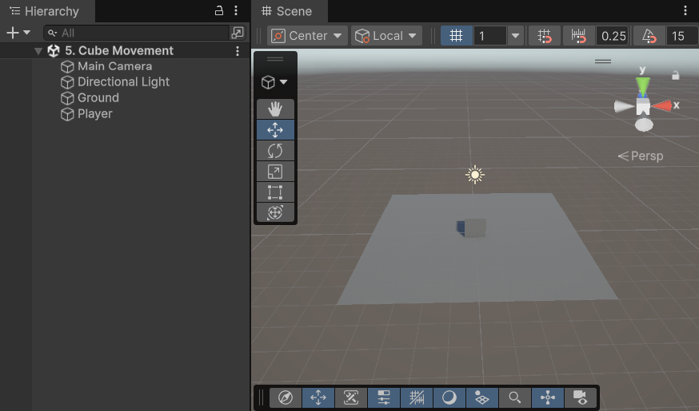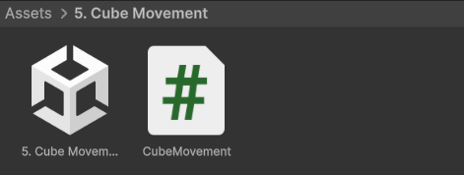

2D Sprite Movement & Boundary Checks

Objective
Work with 2D elements and player input by moving a 2D character sprite using the Arrow Keys or WASD keys. Implement boundary checks to prevent the sprite from moving outside the game screen.

Step 1: Create a New Unity Project
- Open Unity Hub.
- Click New Project.
- Select the 2D Core template.
- Enter a project name.
- Click Create Project.

Step 2: Create a New Scene
- In the Project Window, right-click inside the Assets folder.
- Select Create → Scene.
- Rename the scene as Sprite Movement.
- Open and save the scene.

Step 3: Create the Player Sprite
- Right-click in the Hierarchy.
- Select 2D Object → Sprites → Circle.
- Rename it as Player.
- Set its position above the plane.
  - Position (0, 0, 0)

Step 4: Create a Movement Script
- In the Assets folder, right-click.
- Select Create → C# Script.
- Rename the script as SpriteMovement.
- Open the script in Visual Studio.

Step 5: Write the Script

Replace the default code with:

using UnityEngine;

public class SpriteMovement : MonoBehaviour
{
[Header("Movement Settings")]
public float moveSpeed = 5f;

[Header("Boundary Limits")]
public float minX = -8f;
public float maxX = 8f;
public float minY = -4f;
public float maxY = 4f;

void Update()
{
// Get player input
float horizontal = Input.GetAxis("Horizontal");
float vertical = Input.GetAxis("Vertical");

// Calculate movement
Vector3 movement = new Vector3(horizontal, vertical, 0f);

// Move sprite
transform.Translate(movement * moveSpeed * Time.deltaTime);

// Clamp position within boundaries
float clampedX = Mathf.Clamp(transform.position.x, minX, maxX);
float clampedY = Mathf.Clamp(transform.position.y, minY, maxY);

transform.position = new Vector3(
clampedX,
clampedY,
transform.position.z
);
}
}

Step 7: Attach the Script
- Return to Unity.
- Select the Player sprite.
- Drag the SpriteMovement script onto the Player GameObject.
- OR
- Click Add Component and add SpriteMovement.

Step 8: Configure the Boundary Values

In the Inspector, verify the following values:

Variable | Value
Move Speed | 5
Min X | -8
Max X | 8
Min Y | -4
Max Y | 4

These values can be adjusted depending on your camera size and game area.

Step 9: Test the Scene
- Save the scene (Ctrl + S).
- Click the Play button.
- Use the keyboard to move the sprite.
Controls

Key | Action
W / Up Arrow | Move Forward
S / Down Arrow | Move Backward
A / Left Arrow | Move Left
D / Right Arrow | Move Right

Expected Result
- The sprite moves smoothly in all directions.
- Both WASD and Arrow Keys control movement.
- The sprite cannot move beyond the defined screen boundaries.
- The character remains visible within the game area at all times.

Screenshots
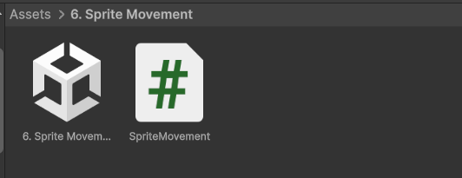
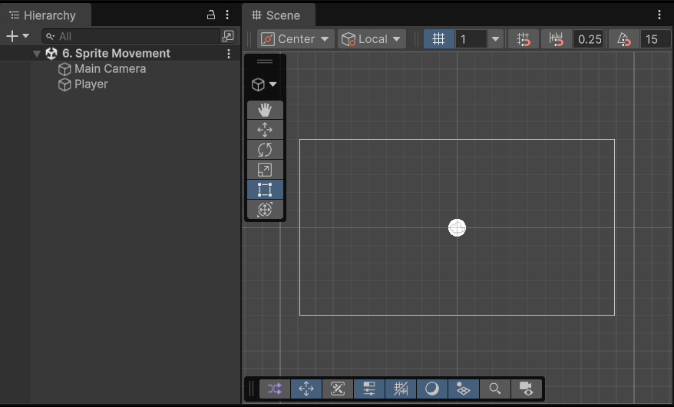

Rigidbody Physics and Colliders

Objective
Understand Unity's Physics Engine by creating a sphere with a Rigidbody component and detecting collisions with a wall using OnCollisionEnter().

Step 1: Create a New Project
- Open Unity Hub.
- Click New Project.
- Select the 3D (Core) template.
- Enter a project name.
- Click Create Project.

Step 2: Create a New Scene
- In the Project Window, right-click inside the Assets folder.
- Select Create → Scene.
- Rename the scene as Physics.
- Open and save the scene.

Step 3: Create the Ground
- In the Hierarchy Window, right-click.
- Select 3D Object → Plane.
- Rename it as Ground.
- Reset the Transform component.

Step 4: Create a Ramp
- Right-click in the Hierarchy.
- Select 3D Object → Cube.
- Rename it as Ramp.
- Set the Transform values:
  - Position (0,0,0)
  - Rotation (0,0,-22.5)
  - Scale (2.5,1,1)
- This cube acts as an inclined plane (ramp).

Step 5: Create a Sphere
- Right-click in the Hierarchy.
- Select 3D Object → Sphere.
- Rename it as Ball.
- Set the Transform values:
  - Position (0, 2.34, 0)

Step 6: Add a Rigidbody to the Sphere
- Select the Ball.
- Click Add Component.
- Search for Rigidbody.
- Add the Rigidbody component.
- Rigidbody Settings
- Property Value
- Mass 1
- Use Gravity Enabled

The sphere will now roll down the ramp due to gravity.

Step 7: Create a Wall
- Right-click in the Hierarchy.
- Select 3D Object → Cube.
- Rename it as Wall.
- Set the Transform values:
  - Position (2, 1, 0)
  - Scale (0.3, 2, 2)

- This cube acts as an obstacle for the sphere.

Step 8: Create the Collision Script
- In the Project Window, right-click inside the Assets folder.
- Select Create → C# Script.
- Rename the script as CollisionController.
- Open the script and replace the default code with:

using UnityEngine;

public class CollisionController : MonoBehaviour
{
private void OnCollisionEnter(Collision collision)
{
Debug.Log(collision);

if (collision.gameObject.CompareTag("Wall"))
{
Debug.Log("Ball hit the wall!");
}
}
}

Step 9: Attach the Script
- Return to Unity.
- Select the Ball GameObject.
- Drag the CollisionController script onto the Ball.

Step 10: Create the Tag "Wall"
- Select the Wall GameObject.
- In the Inspector, click the Tag dropdown.
- Select Add Tag...
- Click the + button.
- Create a new tag named: “Wall”

Important: The tag name must exactly match the text used in the script: CompareTag("Wall")

Step 11: Assign the Tag to the Wall
- Select the Wall GameObject.
- In the Inspector, choose:
- Tag → Wall

Step 12: Save and Run the Scene
- Save the scene (Ctrl + S).
- Click the Play button.
- Observe the sphere rolling down the ramp.
- When the sphere hits the wall, a message appears in the Console.

Expected Output
Ball hit the wall!

Expected Result
- The Sphere falls and rolls due to gravity.
- The Ramp guides the Sphere toward the Wall.
- The Wall blocks the Sphere's movement.
- When the Sphere collides with the Wall, Unity detects the collision and prints a message in the Console.

Screenshots:
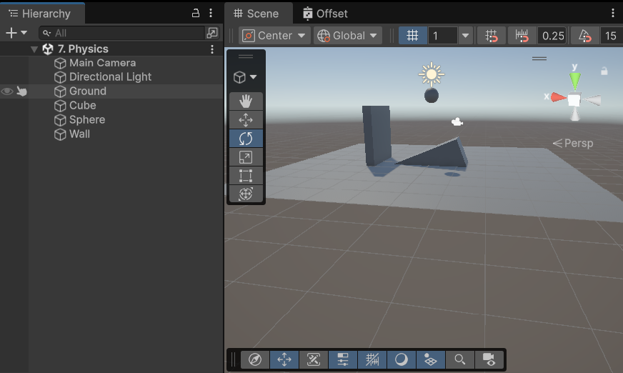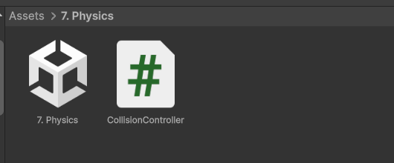

Custom Shaders with Shader Graph

Objective
Create a scrolling road effect using Shader Graph by offsetting a texture over time. This technique is commonly used for endless roads, conveyor belts, and moving backgrounds.

Step 1: Create a New Project
- Open Unity Hub.
- Click New Project.
- Select the 3D (URP) template.
- Shader Graph requires the Universal Render Pipeline (URP).
- Enter a project name.
- Click Create Project.

Step 2: Create a New Scene
- In the Project Window, right-click inside the Assets folder.
- Select Create → Scene.
- Rename the scene as Shader.
- Open and save the scene.

Step 3: Create a Road Plane
- In the Hierarchy Window, right-click.
- Select 3D Object → Plane.
- Rename it as Road.
- Reset the Transform.

Step 4: Create a Shader Graph
- In the Project Window, right-click.
- Select:
- Create → Shader Graph → URP → Lit Shader Graph
- Rename it as:
- RoadShader
- Double-click the shader graph to open it.

Step 5: Create Shader Properties

Create the following properties in the Blackboard:

Name | Type
Texture2D | Texture2D
OffsetSpeed | Vector2

Step 6: Build the Shader Graph
- Add the Following Nodes
1. Time Node
  - Right Click → Create Node → Time
2. Multiply Node
- Connect:
  - OffsetSpeed → A
  - Time → B
3. Tiling And Offset Node
  - Add a Tiling And Offset node.
- Connect:
  - UV → Default UV
  - Offset → Output of Multiply
4. Sample Texture 2D Node
  - Add Sample Texture 2D.
- Connect:
  - Texture → Texture2D Property
  - UV → Output of Tiling And Offset
5. Connect to Base Color
- Connect:
  - Sample Texture 2D → RGB

Shader Flow
OffsetSpeed
│
▼
Multiply ◄──── Time
│
▼
Tiling And Offset
│
▼
Sample Texture 2D
│
▼
Base Color

Step 7: Save the Shader
- Click Save Asset in Shader Graph.
- Close the Shader Graph window.

Step 8: Import the Road Texture
- Import the Seamless Road Texture into the Assets folder.
- Select the texture.
- Texture Import Settings
- Setting Value
  - Texture Type Sprite (2D and UI)
  - Sprite Mode Single
  - Wrap Mode Repeat
- Click Apply.

Step 9: Create a Material
- Right-click in the Assets folder.
- Select Create → Material.
- Rename it as:
- RoadMaterial

Step 10: Assign the Shader
- Select RoadMaterial.
- In the Inspector:
- Shader → Select RoadShader

Step 11: Assign the Texture
- Drag the imported Road Texture into the Texture2D slot.
Set the Offset Speed value:
X Y
0 -0.5

This moves the texture downward continuously.

Step 12: Apply the Material
- Select the Road Plane.
- Drag RoadMaterial onto the Plane.

Step 13: Run the Scene
- Save the scene.
- Click Play.

Expected Result
The road texture scrolls continuously.
The Plane appears as a moving road.

Screenshots:
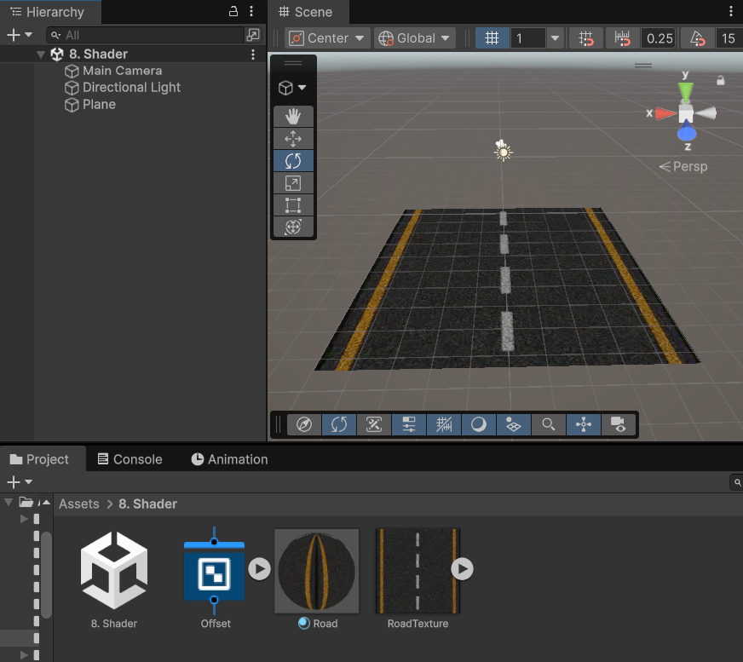

Post-Processing Effects

Objective
Learn how to use Unity's Volume Component to add post-processing effects such as Bloom, Color Adjustments, and Depth of Field to improve the visual quality of a scene.

Step 1: Create a New Project
- Open Unity Hub.
- Click New Project.
- Select the 3D (URP) template.
- Post-processing through Volume Components is supported in the Universal Render Pipeline (URP).
- Enter a project name.
- Click Create Project.

Step 2: Create a New Scene
- In the Project Window, create a new scene.
- Rename the scene as PostProcessing.
- Save the scene.

Step 3: Create Scene Objects
- Create a Plane for the ground.
- Create a few objects such as:
  - Cube
  - Sphere
  - Capsule
- Position them in the scene.
- Add a Directional Light if not already present.

Step 4: Verify URP Settings
- Open:
- Edit → Project Settings → Graphics
- Ensure a Universal Render Pipeline Asset is assigned.
- If using the URP template, this is already configured.

Step 5: Create a Global Volume
- In the Hierarchy Window:
- Right-click → Volume → Global Volume
- Rename it as:
- Global Volume
- A Volume component is automatically added.

Step 6: Create a New Volume Profile
- Select the Global Volume object.
- In the Inspector:
- Click New beside the Profile field.
- Rename the created profile as:
- PostProcessingProfile

Step 7: Add Bloom Effect
- Click Add Override.
- Select:
  - Post-processing → Bloom
  - Enable the following properties:
  - Property Suggested Value
  - Intensity 1.5
  - Threshold 1
  - Scatter 0.7
Bloom creates a glowing effect around bright objects.

Step 8: Add Color Adjustments
- Click Add Override.
- Select:
  - Post-processing → Color Adjustments
  - Enable and modify:
  - Property Value
  - Post Exposure 0.5
  - Contrast 20
  - Saturation 15
This improves scene brightness and color richness.

Step 9: Add Depth of Field
- Click Add Override.
- Select:
  - Post-processing → Depth Of Field
  - Set:
  - Property Value
  - Mode Gaussian
  - Start 3
  - End 15
  - Max Radius 1
Objects far from the camera become slightly blurred.

Step 10: Add Vignette Effect
- Click Add Override.
- Select:
  - Post-processing → Vignette
  - Set:
  - Property Value
  - Intensity 0.3
  - Smoothness 0.5
This darkens the corners of the screen.

Step 11: Configure the Camera
- Select the Main Camera.
- Ensure the following component exists:
- Universal Additional Camera Data
- Verify:
- Render Type = Base
- Post Processing = Enabled

Step 12: Test the Scene
- Save the scene.
- Click Play.

Expected Result
- You should observe:
  - Brighter glowing highlights (Bloom)
  - Enhanced colors and contrast
  - Background blur (Depth of Field)
  - Darkened screen edges (Vignette)
  - More cinematic and realistic visuals

Visual Scripting

Objective
Learn the basics of Unity Visual Scripting by creating a State Machine that continuously rotates a Cube around its Y-axis without writing any code.

Step 1: Create a New Project
- Open Unity Hub.
- Click New Project.
- Select the 3D (Core) template.
- Enter a project name.
- Click Create Project.

Step 2: Create a New Scene
- In the Project Window, right-click inside the Assets folder.
- Select Create → Scene.
- Rename the scene as Visual Scripting.
- Open and save the scene.

Step 3: Create a Cube
- In the Hierarchy Window, right-click.
- Select 3D Object → Cube.
- Rename it as Cube.
- Reset the Transform component.

Step 4: Add a State Machine Component
- Select the Cube GameObject.
- In the Inspector, click Add Component.
- Search for:
  - State Machine
- Select State Machine.

Step 5: Create a New State Graph
- In the State Machine component:
- Click New beside the Graph field.
- Save the graph as:
- CubeRotationGraph
- Double-click the graph to open the Visual Scripting editor.

Step 6: Add an On Update Event
- Right-click in the graph area.
- Search for:
  - On Update
- Add the On Update node.

- The On Update node executes every frame while the game is running.

Step 7: Add a Rotate Node
- Right-click in the graph.
- Search for:
  - Rotate (or) Transform Rotate
- Add the Rotate node.

Step 8: Connect the Nodes
- Connect the On Update flow output to the Rotate flow input.
- Set the rotation values:
Axis Value
X 0
Y 1
Z 0

This causes the cube to rotate around the Y-axis every frame.

Step 9: Save the Graph
- Click Save Asset.
- Return to the Unity Editor.

Step 10: Run the Scene
- Save the scene (Ctrl + S).
- Click the Play button.

Expected Result
- The Cube rotates continuously around the Y-axis.
- No C# script is required.
- Rotation occurs every frame through the Visual Scripting graph.

Creating a UI Canvas

Objective
Create a 2D game main menu screen using Unity UI components. Set the provided assets as the background, logo, and menu buttons.

Assets Used
- DC_Background – Background Image
- DC_Logo – Game Logo
- bt_01 – Start Game Button
- bt_02 – Credits Button
- bt_03 – About Us Button

Step 1: Create a New 2D Project
- Open Unity Hub.
- Click New Project.
- Select the 2D Core template.
- Enter a project name such as DragonCrashersUI.
- Click Create Project.

Step 2: Create a New Scene
- In the Project Window, right-click inside the Assets folder.
- Select Create → Scene.
- Rename the scene as: “MainMenu”
- Open and save the scene.

Step 3: Import UI Assets
- Create a folder named Sprites.
- Import the following assets into the folder:
  - DC_Background
  - DC_Logo
  - bt_01
  - bt_02
  - bt_03
- Select all imported images.
- In the Inspector set:
Setting Value
  - Texture Type Sprite (2D and UI)
  - Sprite Mode Single
- Click Apply.

Step 4: Create a Canvas
- In the Hierarchy:
  - Right Click → UI → Canvas
- Unity automatically creates:
  - Canvas
  - EventSystem
- Select Canvas.
- Canvas Settings
Property | Value
Render Mode | Screen Space - Overlay
UI Scale Mode | Scale With Screen Size
Reference Resolution | 1920 x 1080

Step 5: Set the Background Image
- Right-click Canvas.
- Select:
  - UI → Image
- Rename it as: “Background”
- Assign DC_Background to the Source Image.

Step 5: Set the Background Image
- Right-click Canvas.
- Select:
  - UI → Image
- Rename it as: “Background”
- Assign DC_Background to the Source Image.
- Using the reference fix the correct position

Step 6: Add the Logo
- Right-click Canvas.
- Select:
  - UI → Image
- Rename it as: ”Logo”
- Assign DC_Logo to the Source Image.
- Using the reference fix the correct position

Step 7: Create the Start Game Button
- Right-click Canvas.
- Select:
  - UI → Button (Image)
- Rename it as “StartGameButton”
- Assign bt_01 as the button image.
- Change the button text to: “START GAME”

Step 8: Create the Credits Button
- Duplicate the StartGameButton (Ctrl + D).
- Rename it: “CreditsButton”
- Assign bt_02 as the button image.

Step 9: Create the About Us Button
- Duplicate the CreditsButton.
- Rename it:
  - AboutUsButton
- Assign bt_03 as the button image.

Expected Result
The menu should resemble the provided reference image:

- Full-screen DC_Background image.
- DC_Logo centered near the top.
- Three vertically aligned buttons:
- Start Game
- Credits
- About Us
- Professional game-style menu layout

Game State Management System

Objective
Understand and implement a basic Game State Management System in Unity using C#. Learn how to manage different game states such as Main Menu, Playing, Paused, Game Over, and Win.

Step 1: Create a New Project
- Open Unity Hub.
- Click New Project.
- Select 3D Core.
- Name the project GameStateManagement.
- Click Create Project.

Step 2: Create a New Scene
- Right-click inside the Assets folder.
- Select Create → Scene.
- Rename the scene as GameStateDemo.
- Open and save the scene.

Step 3: Create a Game Manager Object
- In the Hierarchy window:
- Right Click → Create Empty.
- Rename the object as: “GameManager”

Step 4: Create the GameManager Script
- Right-click inside the Assets folder.
- Select Create → C# Script.
- Rename the script as: “GameManager”
- Open the script in Visual Studio.

Step 5: Add the Following Code

using UnityEngine;

public class GameManager : MonoBehaviour
{
public enum GameState
{
MainMenu,
Playing,
Paused,
GameOver,
Win
}

public GameState currentState;

private void Start()
{
ChangeState(GameState.Playing);
}

private void OnApplicationPause(bool pause)
{
if (pause)
ChangeState(GameState.Paused);
}

private void OnApplicationFocus(bool focus)
{
if (focus)
ChangeState(GameState.Playing);
}

public void ChangeState(GameState newState)
{
currentState = newState;

switch (currentState)
{
case GameState.MainMenu:
MainMenuState();
break;

case GameState.Playing:
PlayingState();
break;

case GameState.Paused:
PauseState();
break;

case GameState.GameOver:
GameOverState();
break;

case GameState.Win:
WinState();
break;
}
}

void MainMenuState()
{
Debug.Log("Main Menu");
Time.timeScale = 1;
}

void PlayingState()
{
Debug.Log("Game Playing");
Time.timeScale = 1;
}

void PauseState()
{
Debug.Log("Game Paused");
Time.timeScale = 0;
}

void GameOverState()
{
Debug.Log("Game Over");
Time.timeScale = 0;
}

void WinState()
{
Debug.Log("You Win");
Time.timeScale = 0;
}
}

Step 6: Attach the Script
- Return to Unity.
- Select the GameManager object.
- Drag the GameManager script onto the GameObject.

Step 7: Save and Run
- Save the scene.
- Click the Play button.

Understanding the Script
GameState Enumeration

public enum GameState
{
MainMenu,
Playing,
Paused,
GameOver,
Win
}

Expected Output
- Console Messages
- Game Playing
- Game Paused
- Game Over
- You Win
- Main Menu

Depending on the selected state.

Pathfinding with NavMesh

Objective
Learn how to use Unity's NavMesh system to create AI pathfinding. A player object will move automatically to the location clicked by the user while avoiding obstacles.

Provided Asset
- Level.fbx

Step 1: Create a New Project
- Open Unity Hub.
- Click New Project.
- Select the 3D (Core) template.
- Enter a project name.
- Click Create Project.

Step 2: Create a New Scene
- Right-click inside the Assets folder.
- Select Create → Scene.
- Rename the scene as:
- Navmesh
- Open and save the scene.

Step 3: Import the Level
- Import level.fbx into the Assets folder.
- Drag the model into the Scene Hierarchy.
- Reset its Transform if necessary.

Step 4: Install AI Navigation Package
- Open:
  - Window → Package Manager
- Select Unity Registry.
- Search for:
  - AI Navigation
- Click Install.

Step 5: Create a NavMesh Surface
- Create an Empty GameObject.
- Rename it as: “NavMeshSurface”
- Click Add Component.
- Add:
  - NavMesh Surface

Step 6: Configure the Walls
- Select all wall objects in the imported level.
- Click Add Component.
- Add:
  - NavMesh Modifier
- Enable:
  - Override Area
- Set Area Type:
  - Not Walkable

This prevents agents from walking through walls.

Step 7: Configure the Ground
- Select the ground object.
- Add:
  - Box Collider
The collider is required for mouse raycasting.

Step 8: Bake the NavMesh
- Select the NavMeshSurface object.
- In the Inspector click:
  - Bake
A blue surface appears indicating walkable areas.

Step 9: Create the Player
- Right-click in Hierarchy.
- Select:
  - 3D Object → Cylinder
- Rename it: “Player”
- Position it on the ground.

Step 10: Add NavMesh Agent
- Select the Player.
- Click Add Component.
- Add:
  - Nav Mesh Agent
- Example Agent Settings
- Speed = 3.5
- Angular Speed = 120
- Acceleration = 8

Step 11: Create the Controller Script
- Right-click inside Assets.
- Select:
  - Create → C# Script
- Rename it: “NavmeshController”

Open the script and replace the code with:

using UnityEngine;
using UnityEngine.AI;
using UnityEngine.InputSystem;

public class Navmesh_controller : MonoBehaviour
{
public Camera cam;

public NavMeshAgent agent;

void Update()
{
if (Mouse.current.leftButton.isPressed)
{
Ray ray = cam.ScreenPointToRay(Mouse.current.position.value);
RaycastHit hit;

if (Physics.Raycast(ray, out hit))
{
agent.SetDestination(hit.point);
}
}
}
}

Step 12: Attach the Script
- Select the Player object.
- Drag the NavmeshController script onto the Player.

Step 13: Assign References
- Camera Reference
- Select the Player.
- In the Inspector locate:
  - Cam
- Drag the Main Camera into the field.
- NavMesh Agent Reference
- Locate:
  - Agent
- Drag the Player's NavMesh Agent component into the field.
Step 14: Save and Run
- Save the scene.
- Click Play.

Expected Result
- Clicking anywhere on the walkable ground creates a destination.
- The cylinder automatically moves to the selected location.
- The NavMesh Agent finds the shortest path.
- The player avoids walls and obstacles.
- Movement is smooth and automatic.

JSON Serialization for Login

Objective
Learn how to use JSON Serialization in Unity to store and retrieve user login credentials using a local JSON file. Implement a simple Login and Registration system using TextMeshPro UI.

Step 1: Create a New Project
- Open Unity Hub.
- Click New Project.
- Select the 3D Core template.
- Enter a project name.
- Click Create Project.

Step 2: Create a New Scene
- In the Project Window, create a new scene.
- Rename the scene as:
- LoginSystem
- Save the scene.

Step 3: Create the UI

In the Hierarchy, create the following UI structure:

Canvas
│
├── Panel
│ ├── User_name (TMP Input Field)
│ ├── Password (TMP Input Field)
│ ├── Sign-up (Button)
│ ├── Sign-In (Button)
│ └── Message (TMP Text)

Step 4: Configure Input Fields
- User_name Input Field
- Rename the TMP Input Field as: “User_name”
- Set Placeholder Text:
  - Enter Username
- Password Input Field
- Rename the TMP Input Field as: “Password”
- Set Placeholder Text:
  - Enter Password
- Set:
  - Content Type → Password

This hides the entered characters.

Step 5: Configure Buttons
- Sign-up Button
- Rename button: “Sign-up”
- Button Text:
  - Register
- Sign-In Button
- Rename button: “Sign-In”
- Button Text:
  - Login

Step 6: Create Message Text
- Create a TextMeshPro Text object.
- Rename it: ‘Message”
- Leave text empty.

This will display login and registration messages.

Step 7: Create a Game Manager Object
- Right-click Hierarchy.
- Select:
- Create Empty
- Rename it: “UserAuthManager”

Step 8: Create the Script
- Right-click inside Assets.
- Select:
- Create → C# Script
- Rename it: “UserAuth”
Replace the default code with:

using System.Collections.Generic;
using System.IO;
using TMPro;
using UnityEngine;

public class UserAuth : MonoBehaviour
{
[Header("UI")]
public TMP_InputField usernameInput;
public TMP_InputField passwordInput;
public TMP_Text messageText;

private string filePath;

[System.Serializable]
public class UserData
{
public string username;
public string password;
}

[System.Serializable]
public class UserList
{
public List<UserData> users = new List<UserData>();
}

private UserList userList = new UserList();

void Start()
{
filePath = Path.Combine(Application.persistentDataPath, "users.json");
Debug.Log(filePath);
LoadUsers();
}

public void Register()
{
string username = usernameInput.text;
string password = passwordInput.text;

if (username == "" || password == "")
{
messageText.text = "Enter Username and Password";
return;
}

foreach (UserData user in userList.users)
{
if (user.username == username)
{
messageText.text = "User already exists";
return;
}
}

UserData newUser = new UserData();
newUser.username = username;
newUser.password = password;

userList.users.Add(newUser);

SaveUsers();

messageText.text = "Registration Successful";
}

public void Login()
{
string username = usernameInput.text;
string password = passwordInput.text;

foreach (UserData user in userList.users)
{
if (user.username == username &&
user.password == password)
{
messageText.text = "Login Successful";
return;
}
}

messageText.text = "Invalid Username or Password";
}

void SaveUsers()
{
string json = JsonUtility.ToJson(userList, true);
File.WriteAllText(filePath, json);
}

void LoadUsers()
{
if (File.Exists(filePath))
{
string json = File.ReadAllText(filePath);
userList = JsonUtility.FromJson<UserList>(json);
}
else
{
userList = new UserList();
}
}
}

Step 9: Attach the Script
- Select UserAuthManager.
- Click Add Component.
- Add the UserAuth script.

Step 10: Assign UI References

- Select UserAuthManager and assign:

Script Field | UI Object
Username Input | User_name
Password Input | Password
Message Text | Message

Step 11: Configure Button Events
- Sign-up Button
- Select Sign-up button.
- Under On Click():
  - Click +
  - Drag UserAuthManager
  - Select:
    - UserAuth → Register()
- Sign-In Button
- Select Sign-In button.
- Under On Click():
  - Click +
  - Drag UserAuthManager
  - Select:
    - UserAuth → Login()

Step 12: Run the Application
- Save the scene.
- Click Play.

Registration Test
- Enter username: admin
- Enter password: 1234
- Click Register

Output:
Registration Successful

Login Test
- Enter username: admin
- Enter password: 1234
- Click Login

Output:
Login Successful

Expected Result
- Users can register new accounts.
- User information is stored in a JSON file.
- Existing usernames cannot be registered twice.
- Users can log in with valid credentials.
- Login validation is performed from stored JSON data.

Creating a Cube Rotation Animation

Objective
Learn how to create a basic animation in Unity using the Animation Window. Animate a cube to rotate continuously around the Y-axis.

Step 1: Create a New Project
- Open Unity Hub.
- Click New Project.
- Select the 3D (Core) template.
- Enter a project name.
- Click Create Project.

Step 2: Create a New Scene
- In the Project Window, create a new scene.
- Rename the scene as: “Animation”
- Save the scene.

Step 3: Create a Cube
- In the Hierarchy Window, right-click.
- Select:
  - 3D Object → Cube
- Rename it as: “Cube”
- Reset the Transform component.

Step 4: Open the Animation Window
- Select the Cube GameObject.
- Open:
  - Window → Animation → Animation
- The Animation window appears.

Step 5: Create an Animation Clip
- In the Animation window, click Create.
- Create a new folder named: “Animations”
- Save the animation clip as: “CubeRotate”
- Unity automatically adds:
  - Animation Component
  - Animator Component
to the Cube.

Step 6: Start Recording
- Click the Record button (red circle) in the Animation window.
- Ensure the timeline is at: “0:00”

Step 7: Create the First Keyframe

At time 0 seconds:

Rotation
X Y Z
0 0 0

Unity automatically creates the first keyframe.

Step 8: Create the Final Keyframe
Move the timeline cursor to:
60:00

Change the Cube Rotation to:
X Y Z
0 360 0

Unity automatically creates the second keyframe.

Step 9: Stop Recording
- Click the Record button again to stop recording.
- Save the scene.

Step 10: Configure Looping
- Select the CubeRotate animation clip in the Project Window.
- In the Inspector, enable:
  - Loop Time
- Click Apply.

This allows the animation to repeat continuously.

Step 11: Play the Scene
- Click the Play button.
- Observe the Cube.

Expected Result
- The Cube rotates smoothly around the Y-axis.
- The rotation completes one full revolution (360°) in 60 seconds.
- The animation loops continuously.
- No scripting is required.

